**User’s Manual of 3rd Generation Bluetooth Module**

**Product Name： 3rd Generation Bluetooth Module**

**Model： SOYO-BT24G03**

**Date： 2014-09-08**

**Edition： Version1.0**

**Soyo Technology Development Co. Ltd.**

**All rights reserved**

Content

1.Introduction 1

2.Applications 1

3. Functions 1

3.1 Framework 1

3.2 Functions Description 1

4. Specifications 2

5. Pins Description 3

5.1 Pins Distribution 3

5.2 Pins Functions Declaration 3

6. Key Function Description 5

6.1.1 Module Power up（Starting up at 3.7-4.2V or USB power up） 5

6.1.2 PWRKEY 5

6.1.3 Mode Key 5

6.1.4 Prev / Vol-(Previous music/Previous broadcast/Volume down) 5

6.1.5 Next/Vol+(Next music/Next broadcast/Volume up) 5

6.1.6 Play/Pause(Play/Pause、Accept、Dial、Hang up) 5

6.1.7 CH(Pairing) 6

6.1.8 RESET KEY(Reset) 6

7. Module Diagram and Dimensional Drawing 6

7.1.1. Dimensional Drawing 6

7.1.2 Module Image 7

7.1.3 Pins Drawing 7

8. Reference Applications 8

9 I/O pins 9

10. PCB LAYOUT 10

# 1.Introduction

SOYO-BT24G03 is a highly-integrated, low-cost, low-power, single-chip Bluetooth module. It is characterized by lots of outstanding functions, such as BT call, Micro SD, FM Radio, auxiliary line-in input and suitable for stereo applications. It conforms to Bluetooth 2.1+EDR Standard.

# 2.Applications

* Bluetooth Wireless Audio Transmission( single track or stereo output)
* Bluetooth stereo headset
* Micro SD Reader, Bluetooth Dialer, Bluetooth Speaker etc.

# 3. Functions

## 3.1 Framework

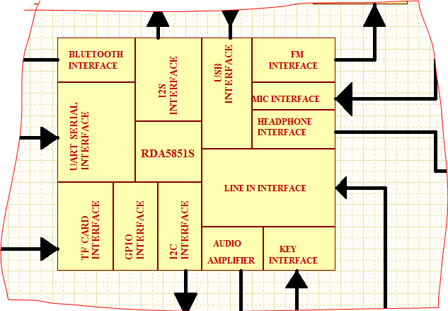

## 3.2 Functions Description

1. Support MP3/WMA/WAV/SBC
2. Bluetooth Stereo Transmission, BT call
3. FM Radio Tuner
4. Micro SD Controller, USB(Slave)
5. Stereo Analog Auxiliary Line Input
6. UART Serial Interface, Self-Customize AT Communications Protocols
7. Internal Integrated Power Management Circuits
8. I2S and I2C Controller
9. Micro SD Program Updating
10. ADC Serial Keypads+ Power on Reset Control, and Hardware Power on
11. Multiple I/O Ports for additional applications
12. USB Sound Adapter

# 4. Specifications

|  |  |  |
| --- | --- | --- |
| Bluetooth Version | | Bluetooth V2.1_ERP |
| Modulation | | PSK 3Mbps TT/4 DQPSK 和8DPSK |
| Profiles | | HFP/HSP,OPP,A2DP/AVRCP,PBAP |
| Sensibility（0.1% BER） | | -82dBm |
| Transmit Power | | Meet Class2 and Class3 ，Max +7dbm |
| Voltage | | 3.4-4.2V(Starting up ) |
| Current | Normal Working | ≦60mA |
| Standby | ≦35mA |
|  | Micro SD Working | ≦41mA |
| Micro SD Standby | ≦24mA |
|  | FM Working | ≦68mA |
| FM Standby | ≦59mA |
|  | AUX IN Working | ≦33mA |
| AUX IN Standby | ≦24mA |
|  | Shutdown | 30uA |
|  | Power off | 35uA |
| SNR | | 65dB(50-15KHz) |
| Distance | | 10m |
| FM Frequency Range | | 65-108MHz |
| Micro SD | | MAX 32G |
| Work Temperature | | -20 to +50℃ |
| Dimension | | 17.51x 16.66x 0.8mm |

# 5. Pins Description

## 5.1 Pins Distribution

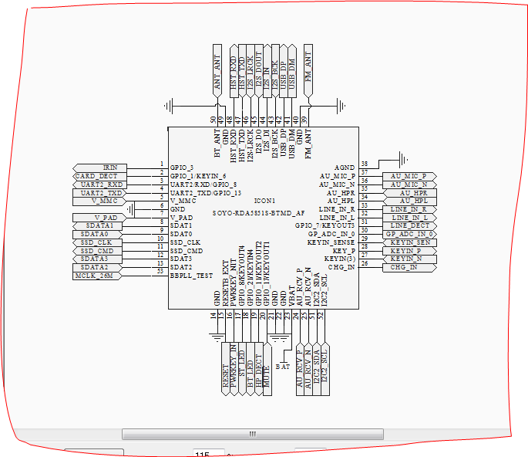

## 5.2 Pins Functions Declaration

|  |  |  |
| --- | --- | --- |
| Pins | Name | Description |
| 1 | GPIO_3 | GPIO/IR Rx, Interrupt supported |
| 2 | GPIO_1/KEYIN_6 | GPIO/Default Micro SD Detection，Interrupt Supported |
| 3 | UART2/RXD/GPIO_8 | UART2 Serial/GPIO, no Interrupting |
| 4 | UART2_TXD/GPIO_13 | UART2 Serial/GPIO, no Interrupting |
| 5 | V_MMC | Micro SD Power Supply（2.98V Output） |
| 6 | GND | Ground |
| 7 | V_PAD | 2.98V Output |
| 8 | SDAT1 | Micro SD Data Line |
| 9 | SDAT0 | Micro SD Data Line |
| 10 | SSD_CLK | Micro SD Clock |
| 11 | SSD_CMD | Micro SD Communication |
| 12 | SDAT3 | Micro SD Data Line |
| 13 | SDAT2 | Micro SD Data Line |
| 14 | GND | Ground |
| 15 | RESETB_EXT | Reset |
| 16 | POWKEY_INT | Power Key，Active High |
| 17 | GPIO_8/KEYOUT4 | GPIO/Default Status Light(Green LED)，no External Interrupt，Compound Matrix Keypad |
| 18 | GPIO_21/KEYIN4 | GPIO/Default Bluetooth Status Light（Blue LED）no External Interrupt，Compound Matrix Keypad |
| 19 | GPIO_11/KEYOUT2 | GPIO/Default Earphone Detection，no External Interrupt，Compound Matrix Keypad |
| 20 | GPIO_17/KEYOUT1 | GPIO, no External Interrupt，Compound Matrix Keypad |
| 21 | GND | Ground |
| 22 | GND | Ground |
| 23 | VBAT | Module Power Supply 3.4-4.2V |
| 24 | AU_RCV_P | Audio Differential Input Positive |
| 25 | AU_RCV_N | Audio Differential Input Negative |
| 26 | CHG_IN | Internal Charging（Need External Expanding） |
| 27 | KEYIN_N | Matrix port In |
| 28 | KEYIN_P | ADC Keypad |
| 29 | KEYIN_SEN | ADC Keypad |
| 30 | GP_ADC_IN_0 | ADC Keypad(Reservation) |
| 31 | LINE_DECT | GPIO/Default LINE Detection，External Interrupt，Compound Matrix Keypad |
| 32 | LINE_IN_L | Line In Left |
| 33 | LINE_IN_R | Line In Right |
| 34 | AU_HPL | Audio Single Track Left |
| 35 | AU_HPR | Audio Single Track Right |
| 36 | AU_MIC_N | MIC Input Negative |
| 37 | AU_MIC_P | MIC Input Positive |
| 38 | AGND | Analog Ground |
| 39 | FM_ANT | FM Antenna |
| 40 | GND | Ground |
| 41 | USB_DM | USB DATA- |
| 42 | USB_DP | USB DATA+ |
| 43 | I2S_BCK | Serial Clock |
| 44 | I2S_IN | Audio Data Input |
| 45 | I2S_DOUT | Audio Data Output |
| 46 | I2S_LRCK | Flame Clock |
| 47 | HST_TXD | DEBUG |
| 48 | HST_RXD | DEBUG |
| 49 | GND | Ground |
| 50 | BT_ANT | Bluetooth Antenna |
| 51 | I2C2_SDA | I2C Data |
| 52 | I2C2_SCL | I2C Clock |
| 53 | BBPLL_TEST | Clock Output Testing（For I2S Main Clock） |

# 6. Key Function Description

## 6.1.1 Module Power up（Starting up at 3.7-4.2V or USB power up）

## 6.1.2 PWRKEY

Press PWR KEY to power on, get in Bluetooth mode by default and hear the Bluetooth Indicating Voice. Simultaneously LED twinkles between blue and green. After pairing successfully Blue LED twinkles.

## 6.1.3 Mode Key

Press PWR KEY to power on, get at Bluetooth mode by default. Press Mode Key to be at Micro SD Controller mode (Green LED twinkles). Press Mode Key again to be at FM Radio mode (Green LED twinkles). Press Mode Key next time to be at Line In mode (Green LED twinkles).Press Mode Key next time to be back at Bluetooth Mode and loop. Each time after changing the mode, speaker plays corresponding indicating voice and LEDs twinkle accordingly. When plugging in line input, it interrupts current mode automatically and changes it into LINE-IN mode. Then you can switch modes by pressing mode key.

At Bluetooth mode if no Bluetooth device is connected within 5 minutes, it shut off automatically to save the battery. Press PWRKEY to restart if needed.

## 6.1.4 Prev / Vol-(Previous music/Previous broadcast/Volume down)

6.1.4.1 Previous music at the micro SD and Bluetooth mode

6.1.4.2 Previous broadcast at the FM mode

6.1.4.3 Invalid at LINE IN mode

6.1.4.4 Holding down for over 2 seconds, volume decreases. There will be “dudu” indicating voice when minimum volume. (Apply to all modes)

## 6.1.5 Next/Vol+(Next music/Next broadcast/Volume up)

6.1.5.1 Next music at the micro SD and Bluetooth mode

6.1.5.2 Next broadcast at the FM mode

6.1.5.3 Invalid at LINE IN mode

* + - 1. Holding down for over 2 seconds, volume increases. There will be “dudu” indicating voice when maximum volume. (Apply to all modes)

## 6.1.6 Play/Pause(Play/Pause、Accept、Dial、Hang up)

6.1.6.1 Play/Pause、Accept、Dial、Hang up at Bluetooth mode. After pairing completed, hold down for over 3 seconds or press twice consecutively to dial last number. Handling the call, press to accept; hold down for over 3 seconds to reject. Press in the call to hang up.

* + - 1. Play/Pause at micro SD mode.
      2. FM Mode

Hold down for over 3 seconds to auto-search. (Starting from the lowest at FM frequency range, green LED flashing) It auto-save the broadcasts and continue. The first-saved broadcasts will be played after auto-searching. You can press PLAY/PAUSE Key to control FM radio to pause and start again. Auto-search broadcasts when first time at FM mode after Device programming.

* + - 1. Play/Pause at Line In mode.

## 6.1.7 CH(Pairing)

6.1.7.1 Press to pair and abolish pairing.

## 6.1.8 RESET KEY(Reset)

Software reset when system halted. Press PWR Key to restart.

# 7. Module Diagram and Dimensional Drawing

## 7.1.1. Dimensional Drawing

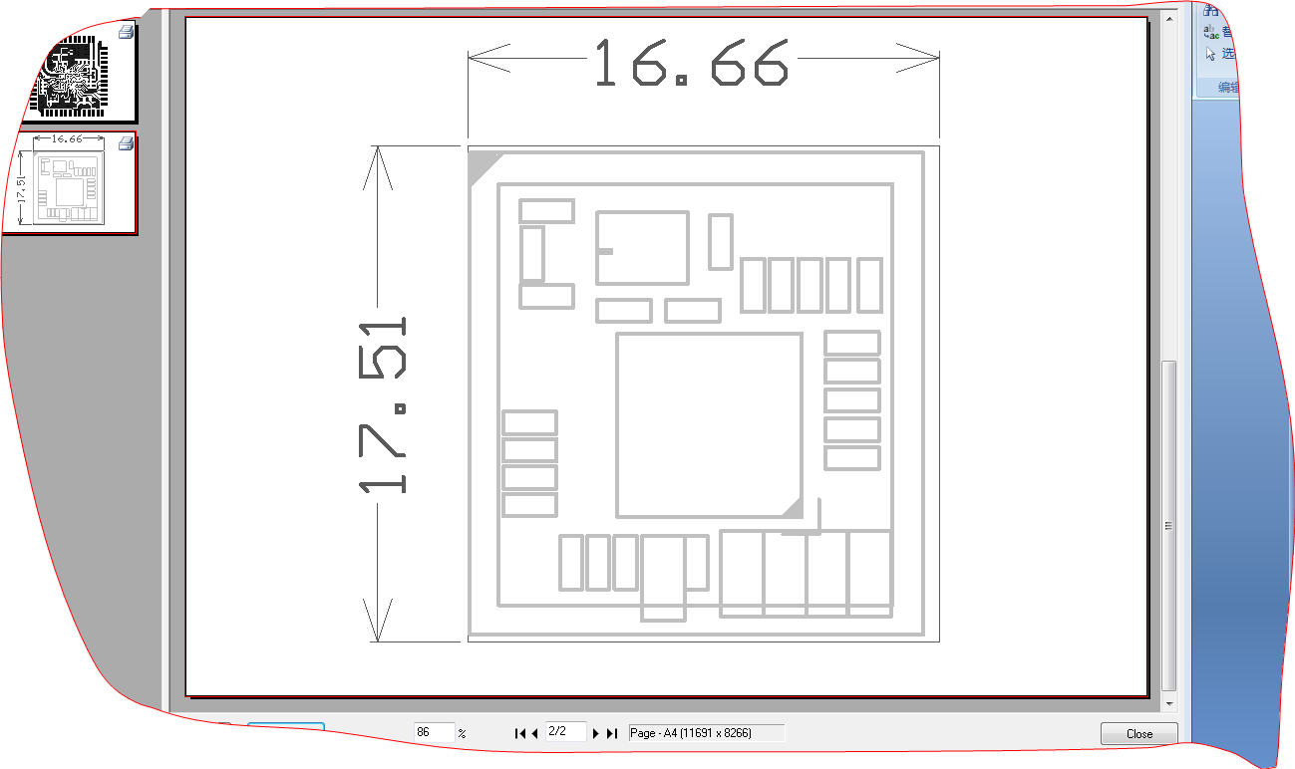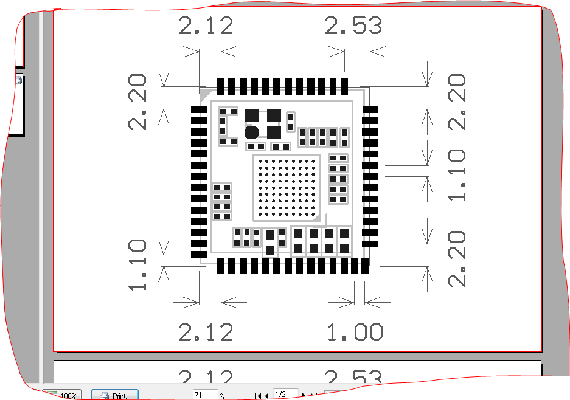

## 7.1.2 Module Image

## 7.1.3 Pins Drawing

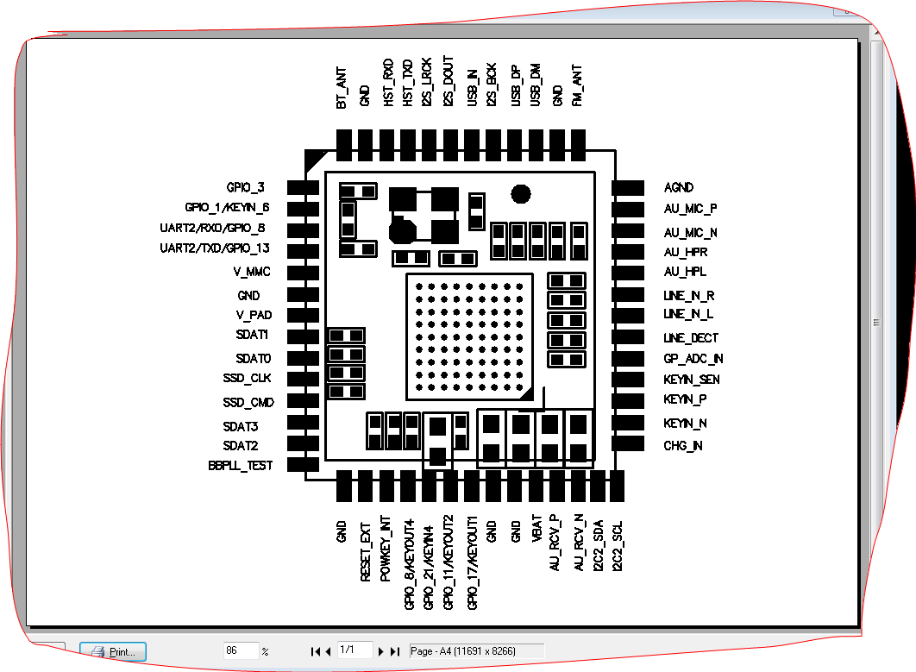

# 8. Reference Applications

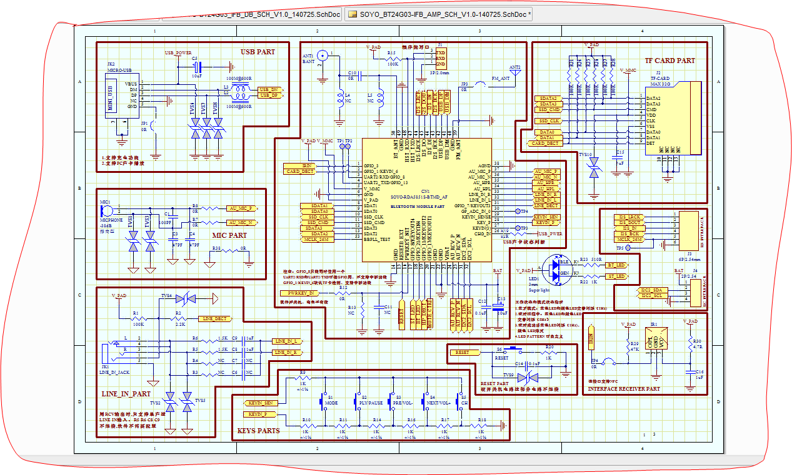

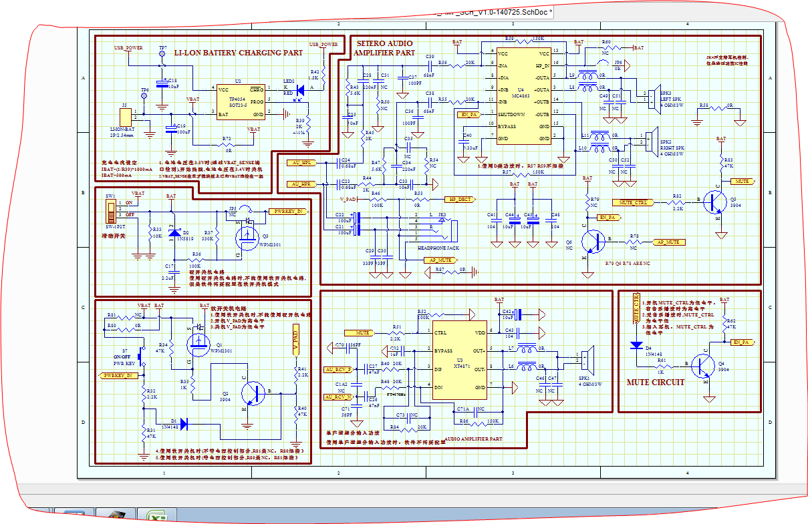

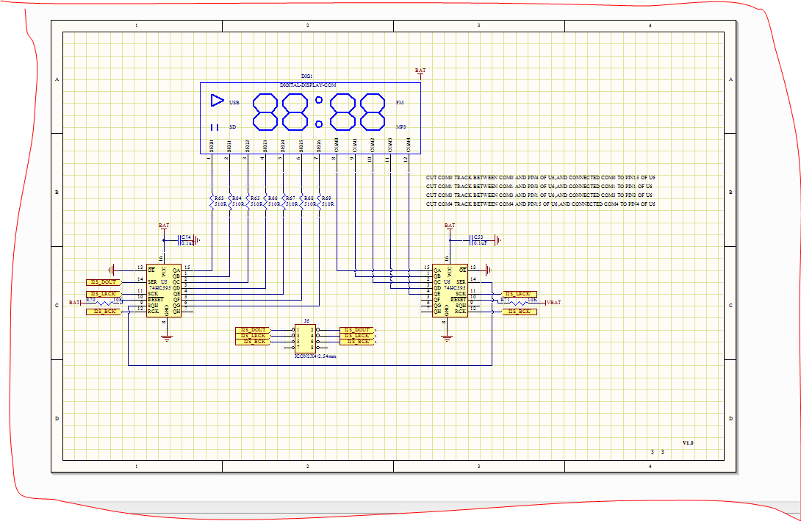

# 9 I/O pins

|  |  |  |  |
| --- | --- | --- | --- |
| Pin No. | Definition | Remark |  |
| 31 | GPIO_7/KEYOUT3 | Default line in detecting/Normal I/O, response to interruption, compound matrix keypad |
| 19 | GPIO_11/KEYOUT2 | Default earphone detecting/Normal I/O, not response to interruption, compound matrix keypad |
| 20 | GPIO_17/KEYOUT1 | Default external PA Standby, compound matrix keypad |
| 18 | GPIO_21/KEYIN4 | Default BT_LED output, low electrical level valid, compound matrix keypad |
| 17 | GPIO_8/KEYOUT4 | Default LED1 output, low electrical level valid, compound matrix keypad |
| 1 | GPIO_3 | Default IR import/Normal I/O, Response to external interruption |
| 2 | GPIO_1/KEYIN6 | Default Card detecting/Normal I/O, Response to external interruption, compound matrix keypad |
| 3 | UART2_RXD/GPIO_8 | Default Uart port |
| 4 | UART2_TXD/GPIO_13 | Default Uart port |

|  |  |  |  |  |  |
| --- | --- | --- | --- | --- | --- |
| Control Instruction | | | | | |
| LED Indicator | Charge indicator | Bluetooth Indicator | | Reserved LED Indicator , Self- defined | |
| Off when D6 full | GPIO_21 | | GPIO_8 | |
| CARD | DATA | CMD | CLK | | DECT |
| D0-D3 | SSD_CMD | SSD_CLK | | GPIO_1 |
| MUTE | Earphone Mute Control | | Power Amplifier Mute Control | | |
| GPIO_17( Low electrical valid) | |  | | |
| OTHER | Self-Define based on ports | | | | |

# 10. PCB LAYOUT

1. Bluetooth antenna should be placed avoiding metal, because metal weaken antenna function. It is forbidden to place ground or wire under Bluetooth antenna.
2. Metal component such as battery and chip should not overlap antenna. Module antenna is supposed to be placed at the edge of PCB.
3. Signals and Bluetooth device are largely influenced by the environment. For instance, obstacles such as trees and metal absorb signals to a certain extent. And therefore transmission distance is often influenced in practice.
4. As Bluetooth module fits in certain systems placing inside cases, metal cases should be avoided.